3.1.1 Largest of three numbers
ALGORITHM
- Start
- Input three integers a, b, c
- Comparing 3 numbers
- Print Largest of three numbers
- Stop

FLOWCHART

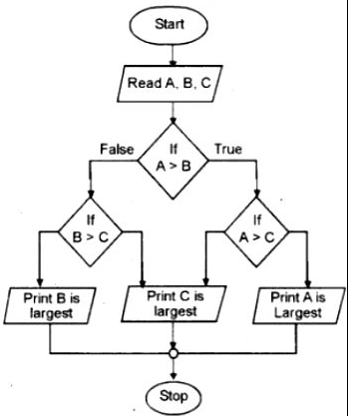

PYTHON CODE
a=int(input())
b=int(input())
c=int(input())
print(max(a,b,c))

